**Experiment 5**

**Jenkins Master-Slave**

**Aim**

To understand the Master-Slave methodology of Jenkins

**Steps**

1. Create a Slave Node on Jenkins
   1. Go to Dashboard > Manage Jenkins > Nodes > New Node
   2. Give a name to the node, select Permanent Agent & click Create

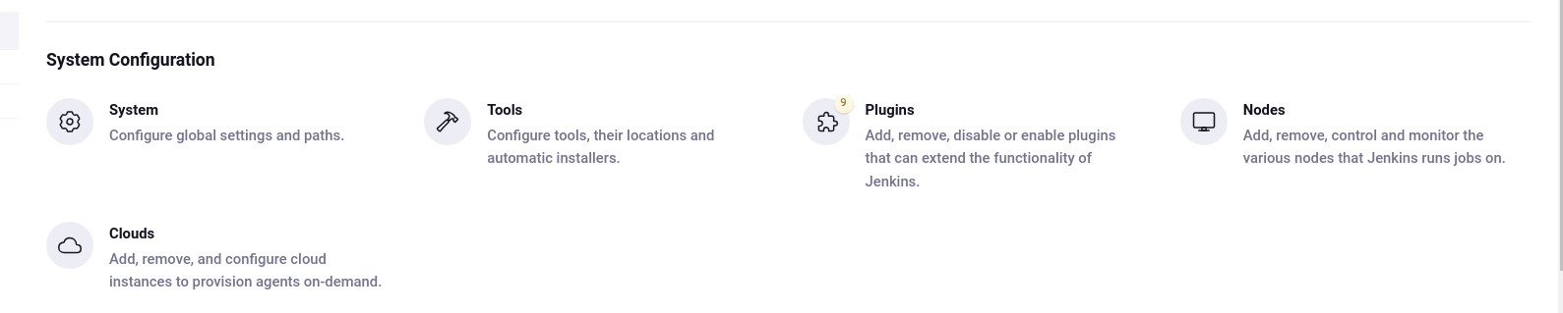

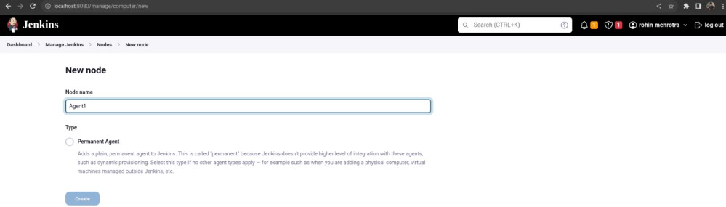

• Set as permanent agent

# • Label it as Agent1

• Set remote root repo path of your local system :

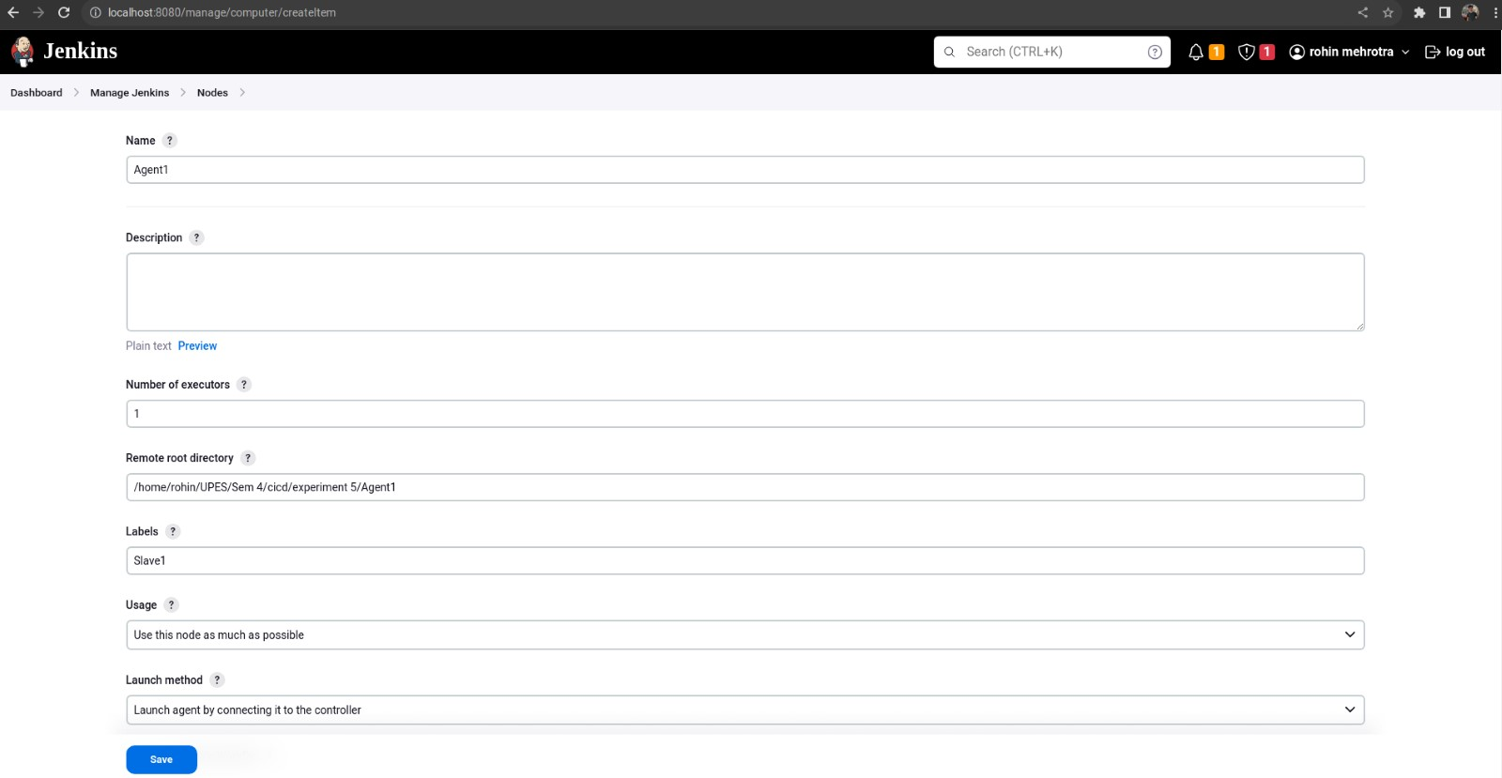

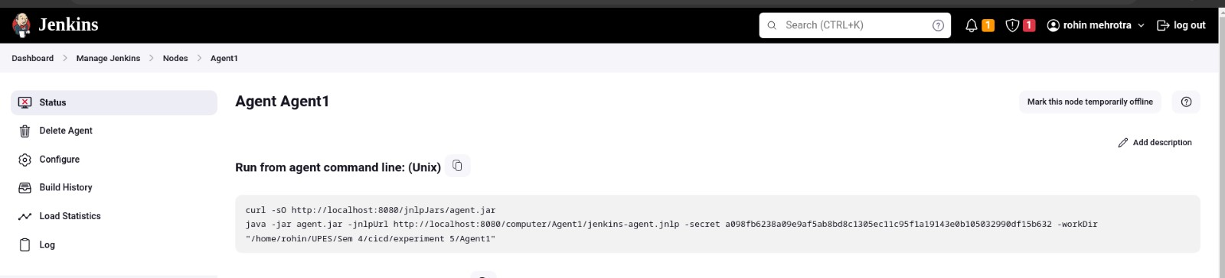

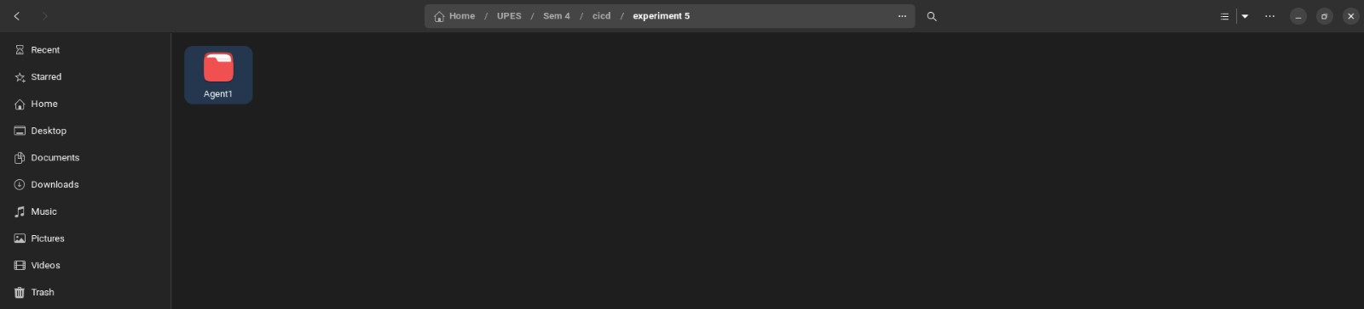

# • Then save it 1. Go to your cmd of slave1 and run these commands

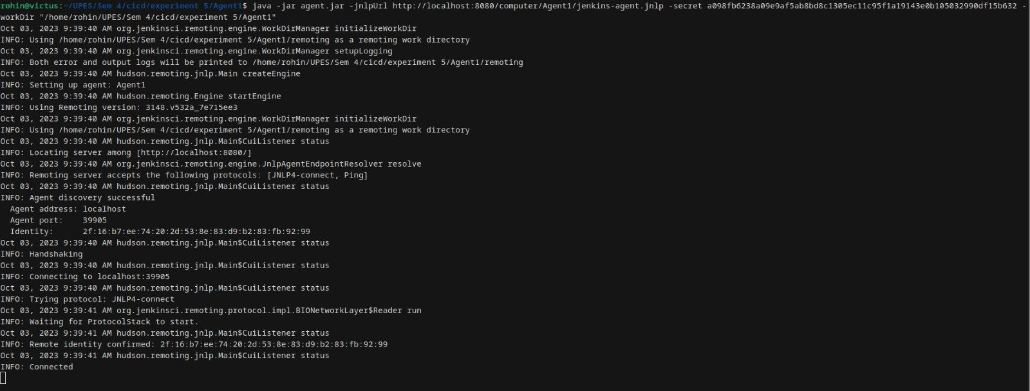

This slave is connected and now using this slave we’ll make a build-

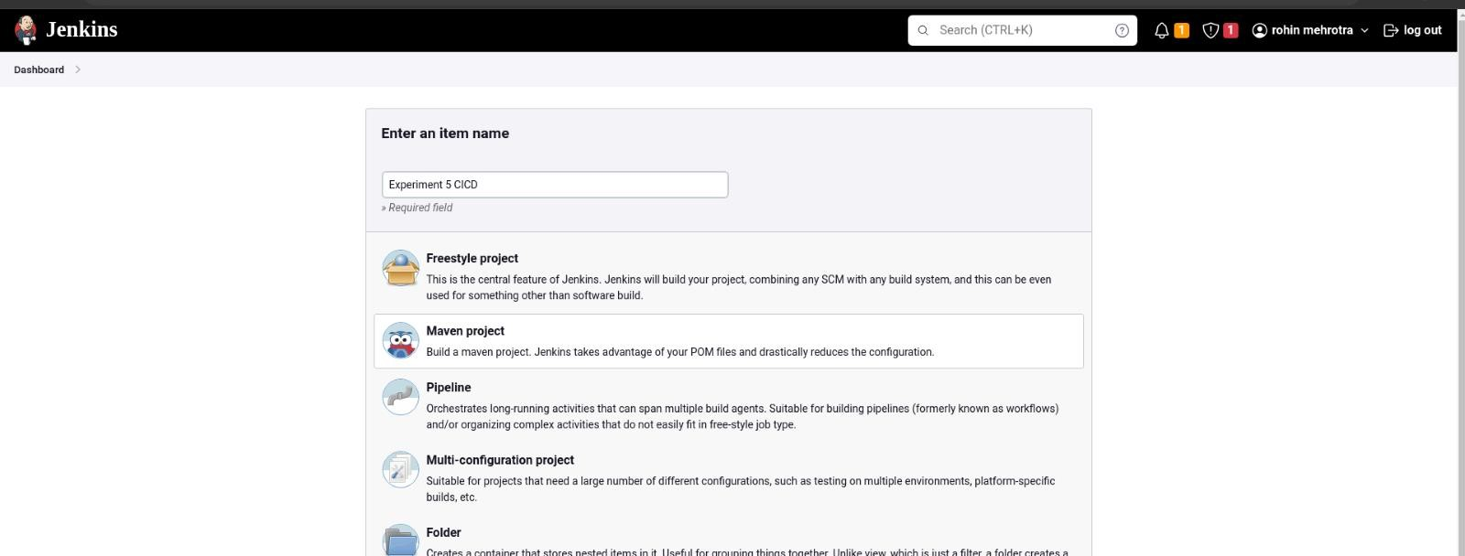

# Make a new maven project and connect it to github project for making automatic build(cicd-lab-5)

